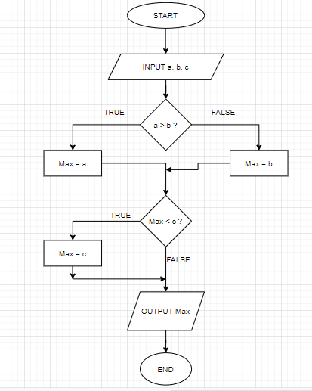

*START*

*INPUT a, b, c*

*IF (a > b)*

*Max = a*

*ELSE*

*Max = b*

*ENDIF*

*IF (c > Max) THEN*

*Max = c*

*ENDIF*

*PRINT ‘Max’*

*END*